Augustus Mendy

Southern New Hampshire University

CS-360-10441-M01

Professor Brian Holbert

May 25, 2025

**3-2 Assignment Android Studio Introduction**

* Create a new Android Studio project with no activity.
* Name the project and include your name in the title.
* Select API 34 as the target SDK.

* Create a new file titled "activity_main.xml". Create a new layout of your choosing. The layout must include a button, a TextView, and a plain text.

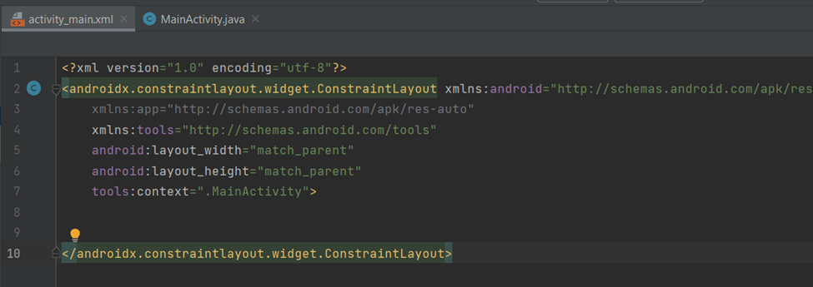

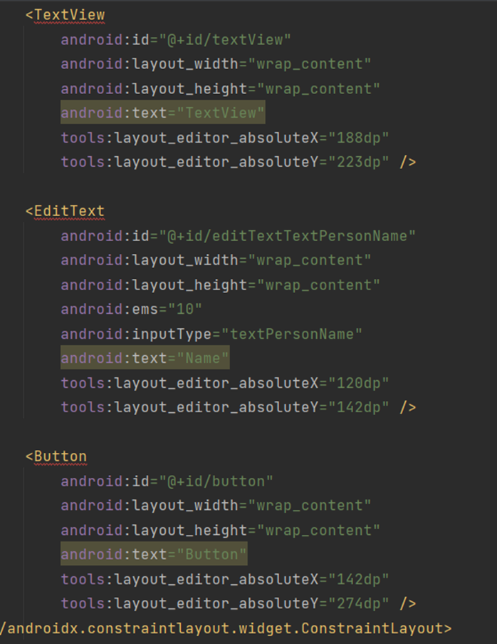

* Identify the Android Studio elements using relevant names. To accomplish this task, complete the following:
* To accomplish this task, complete the following actions:
* Name the button’s text as “Say Hello”.

* Remove all text from the TextView.

* Label the ID of the button as “buttonSayHello”.

* Label the Plain tText as “nameText”.

* Label the TextView as “textGreeting”.

* Discuss any challenges experienced with Android Studio.

Now that you have explored Android Studio, talk about your initial experience and ask any questions.

Explain any challenges you are having accessing or using Android Studio so that you will be prepared for later work in this course.

I had a good overall experience with Android Studio. I thought it was an effective tool for creating Android apps. I do believe that the debugging features and documentation might still be improved, though. Having more Android Studio experience will undoubtedly help me overcome these obstacles. Learning more about this strong technology and applying it to create fantastic Android apps excites me.

Reference:

“Zure Application:

<https://play.google.com/store/apps/details?id=com.zure.stockzure>  
the Inventory Management by Industrial IT:

https://play.google.com/store/apps/details?id=nl.industrialit.warehousemanagement”.